**Why testing is required**?

point out defect in development phase customer reliability.

2) **What types of application we test**

Fictional performance

Manual testing Automated

**3)what is SDLC and different phases in SDLC?**

Software development life cycle (SDLC) is a process to develop the application

Different phases like:

Requirement Analysis and planning: Senior team members analyze the requirements/input given by customers/business users. They will check whether the requirement is feasible or not (can be done or not). They also identify the risks associated with project.

Note: this high level requirement will be written in BRD (Business Requirement document) by Business Analyst

Define/Design: in the define stage Business Analyst define more details about requirements (which are in BRD) in the form of SRS (software requirement specification) or Use Case diagram.

As part of design,

Senior Developers write High Level Design Document (HLD)

Developers write Low Level Design Document (LLD)

Seniors Tester write Test Planning document

Implementation/Development: Developers write the code for the requirements

Testers write test cases as per SRS

Testing: Execute the test cases what we prepared in previous stage

Deployment : Release the tested code to production

Maintenance : Support team monitoring the system that is running in production

**2) what is waterfall in SDLC?**

**what is the process in agile model**

combination of iteration & incremental process models with focus …. Which requirement and solution evolve through collaboration between self n organizing teams

**what is scrum methodology**

part of agile methodology

what is daily standup meeting and what we discuss

what we done in yesterday. We have report to manager about task status of product .

Agile methodology

scrum

sprint

**what is user story/feature/sprint back log items and tasks in user story**

task details to do in next sprint

Sprint backlog : contains user stories popped off

**what is sprint planning and spring retro**

**what is burndown chart and velocity**

**what is product backlog item and sprint backlog items**

prioritized features list containing description(user stories) of functionality desired in product

what is user acceptance criteria test cases

Acceptance testing, a testing technique performed to determine whether or not the software system has met the requirement specifications. The main purpose of this test is to evaluate the system's compliance with the business requirements and verify if it is has met the required criteria for delivery to end users.

There are various forms of acceptance testing:

User acceptance Testing

Business acceptance Testing

Alpha Testing

Beta Testing

**what is v model**?

**what is STLC?**

Software Testing Life Cycle (STLC) is the testing process which is executed in systematic and planned manner. In STLC process, different activities are carried out to improve the quality of the product. ... Test Execution

**what is defect?**

A programmer while designing and building the software can make mistakes or error. These mistakes or errors mean that there are flaws in the software. These are calleddefects.

**how to arise a defect and what we specify while logging defect?**

defect lifecycle

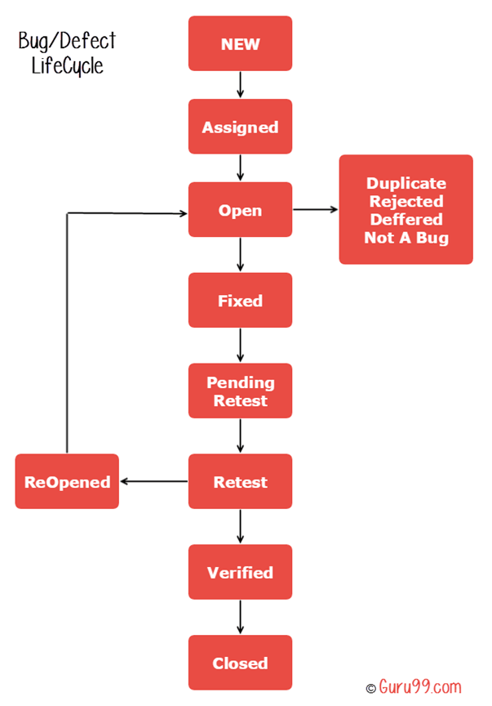

**Different types of testing?**

**when do we use regression testing**?

Change the code according to requirement

New feature added to code

After Defect fixing

**when do we use integration testing?**

Data flow between two different type modules (Web services , API , Database) page has components

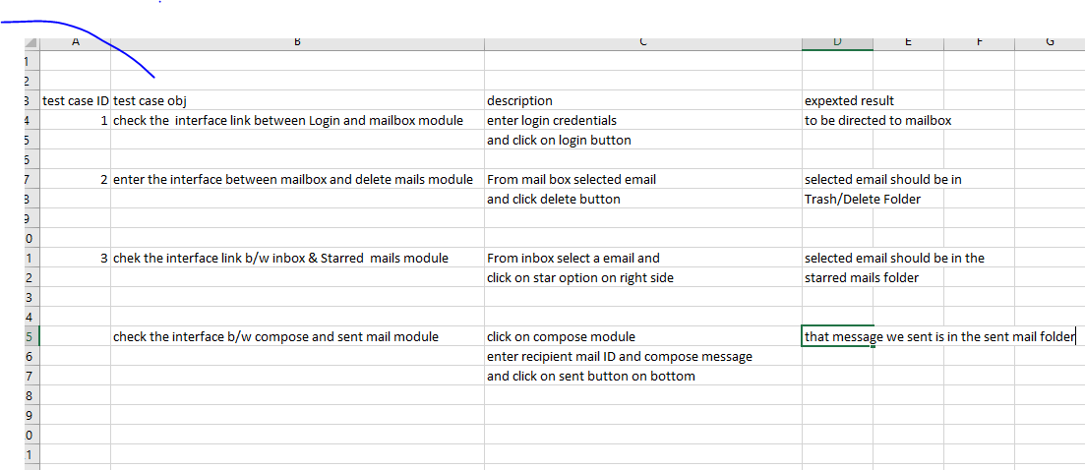

**when do we use smoke testing and sanity testing?**

This is First testing we done after getting build from devolopers

It is software testing to check critical Functionalities or working or not. It is done before any functional or regression testing done.

As soon as we click on Compose Link in G Mail or yahoo etc its should go to compose page , if it does not go there is a critical Bug which has to be fixed for Further processes.

assume we have a user name and password and we login to   
gmail,there we caet the gmail inbox page.  
so it is called as a critical bug.  
so testing the critical feature of feature is called as   
smoke

.. URL

Username & password

Sanity testing is performed after the build has clear the Smoke test and has been accepted by QA team for further testing, sanity testing checks the major functionality with finer details.

Able to login/logout

Login page after logout

Check links if any

**what is unit testing**?

Unit testing is a confusing part of the software development process. Unit testing involves individually testing unit of code separately to make sure that it works on its own, independent of the other units.

For example you are testing a function; whether loop or statement in a program is working properly or not than this is called as unit testing. A beneficial example of a framework that allows automated unit testing is JUNIT (a unit testing framework for java).

**what is UAT?**

To meet the requirements . Final stage of testing before submitting to client

Prerequisites of User Acceptance Testing:

Following are the entry criteria for User Acceptance Testing:

Business Requirements must be available.

Application Code should be fully developed

Unit Testing, Integration Testing & System Testing should be completed

No Showstoppers, High, Medium defects in System Integration Test Phase -

Only Cosmetic error are acceptable before UAT

Regression Testing should be completed with no major defects

All the reported defects should be fixed and tested before UAT

Traceability matrix for all testing should be completed

UAT Environment must be ready

Sign off mail or communication from System Testing Team that the system is ready for UAT execution

**what is alpha and beta testing?**

Alpha : This is a form of internal acceptance testing performed mainly by in-house software QA and testing teams. Alpha testing is the last testing done by test teams at development site after the acceptance testing and before releasing the software for beta test. Alpha testing can also be done by potential users or customers of the application. But still this is a form of in-house acceptance testing.

Beta : This is a testing stage followed by internal full alpha test cycle. This is the final testing phase where companies release the software for few external user groups outside the company test teams or employees. This initial software version is called as beta version. Most companies gather user feedback in this release.

when do we use white box testing and block box testing?

what we will do if we don’t have a time to test all stories?

what we will do if come across any severity issue before release day?

If the client is not ready to give some time then analyse the impact of defect/bug and try to find workarounds for the defect and mention these issues in the release notes as known issues or known limitations or known bugs. Here the workaround means remedy process to be followed to overcome the defect effect.

Normally this known issues or known limitations(defects) will be fixed in next version or next release of the software.

**when do we use automation testing**?

**what tester will do in each phase of SDLC?**

 Tester prepares the Test cases, Test Scenarios  from the SRS  
2.  Using the script the tester performs different kinds of testing (Regression, Function)  
3. Tester Notes the results(pass/Fail)  
4. If Result=Fail then the scenario is raised in the Test director   
5. Once its fixed by the developer the tester performs a regression testing

Requirement

Desingn

Coding

Testing

**difference between load and performance testing?**

Performance testing is the testing, which is performed, to ascertain how the components of a system are performing, given a particular situation. Resource usage, scalability and reliability of the product are also validated under this testing.

Load testing is meant to test the system by constantly and steadily increasing the load on the system till the time it reaches the threshold limit. It is the simplest form of testing which employs the use of automation tools such as LoadRunner or any other good tools, which are available

**different types of non-functional testing types?**

Load/Performance testing.

Compatibility testing.

Localization testing.

Security testing.

Reliability testing.

Stress testing.

Usability testing.

Compliance testing.

**what is test case?**

A Test Case is a set of actions executed to verify a particular feature or functionality of your software application.

what is test plan/test strategy document

Ans: Test plan document contains different section like

       Types of testing :

       Exit and Entry criteria :

**what is TDD and BDD (cucumber framework)**

**what is priority and severity in defect?**

defect severity can be defined as the degree of impact a defect has on the development or operation of a component application being tested.

Levels

Critical

Major

Medium

Low

Defect Priority states the order in which a defect should be fixed. Higher the priority the sooner the defect should be resolved.

Defects that leave the software system unusable are given higher priority over defects that cause a small functionality of the software to fail.

HIGH

Medium

Low

**how to estimate test cases?**

Work Breakdown Structure.(break down project into small pieces)

Function Point/Testing Point Analysis.(measure the size and weightage)

Percentage of development effort method.

3 point Estimation(estimate method on statistical data)

Percentage distribution.

Best Guess.

**what is most challenge defect u came across**?

**how to deal the production defects?**

Ans: normally end user will report this issue.

       we need to talk to them and reproduce the issue with test logins

  Create defect in defect tool under the production release version

  developers will fix the issue

  we (QA) test the issue on production version code and release the fix to proudction after we verify

 we have to create a defect on current sprint/release so that developer will add this code to the current sprint/release

test design review steps

if we dont have time to test call test cases what we will do

how we learn the functionality of system?

what are the tools to manage defects/stories?

who will assign the work?

types of test metrics we use normally

Software testing metrics - Improves the efficiency and effectiveness of a software testing process."

Software testing metrics or software test measurement is the quantitative indication of extent, capacity, dimension, amount or size of some attribute of a process or produ

Process metrics

Product Metrics

Project metrics

what is traceability matrix?

what are typical environments we have in projects

what is development environment

what is QA environment

what is production environment

what are different defect metrics and measurements we prepare

what are weakness and strong points

What is staging environment